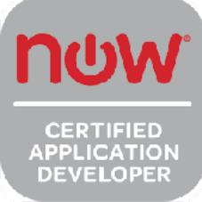
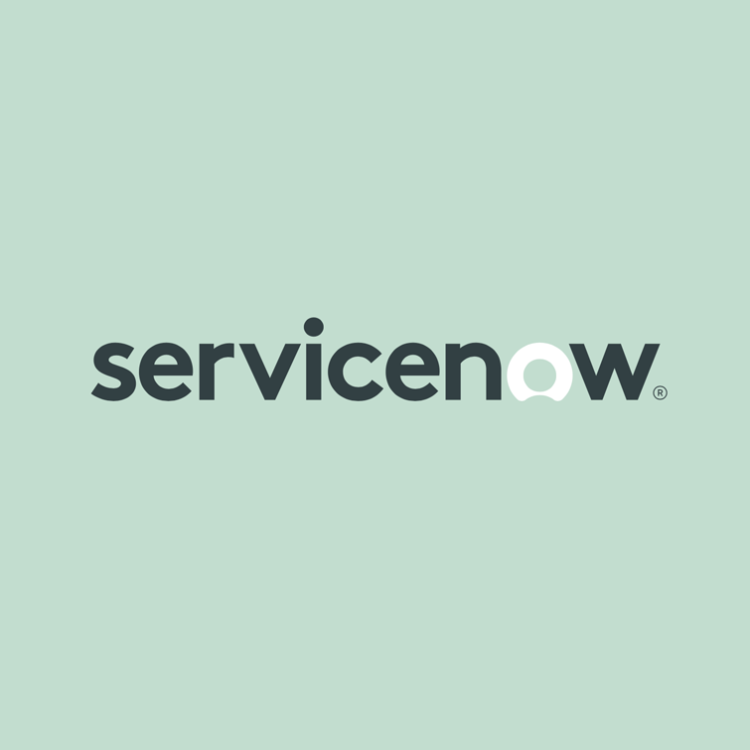
P MALAVI  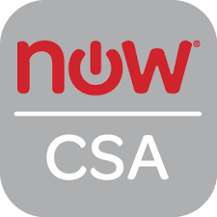
ServiceNow Lead Architect
malavi.snow@gmail.com
Phone: +1 (972) 379-9341

SUMMARY PROFESSIONAL:
- 12+ years of comprehensive ServiceNow experience with expertise in ITSM, HRSD, ITOM, CSM, GRC, and Cloud AIOps modules.
- Served as Lead Architect, Developer, and SME across multiple client environments, including Northern Trust, Home Depot, Larsen & Toubro Technology Services, Larsen & Toubro Infotech.
- Led end-to-end implementation of Customer Service Management (CSM) for global enterprises, integrating ETL data pipelines and Omni-Channel support.
- Architected Order Management for Telecom (OMT) workflows, integrating approval chains, fulfillment, inventory, and tracking dashboards.
- Built secure, role-based workspaces and Virtual Agent chat flows to optimize service agent efficiency and customer resolution rates.
- Implemented HR Case and Lifecycle Events using flow designer, templates, and activity sets to automate onboarding and offboarding.
- Adept at working closely with business stakeholders to gather and refine requirements, design scalable workflows, and implement custom applications and modules.
- Configured Employee Center and Pro, streamlining self-service access to HR services and knowledge articles.
- Developed HR dashboards and SLA compliance reports, reducing ticket resolution times and improving operational KPIs.
- Integrated Workday and SuccessFactors with HRSD to auto-create and route HR cases based on employee actions.
- Proven track record of leading onshore/offshore teams and collaborating across geographies to deliver high-impact ServiceNow solutions, including Agile Management, Access and Identity Management, and telecom support processes.
- Led ITOM Discovery and Service Mapping projects, customizing patterns and IRE rules for accurate CI population.
- I am skilled in report development, process improvement initiatives, and integration with third-party tools, LDAP, and custom APIs. Highly collaborative, solution-oriented, and adaptable to fast-paced environments
- Created and managed MID Servers, clustering, and probe configurations for distributed and failover discovery.
- Engineered CMDB dashboards, stale CI detection, compliance audits, and integration with SolarWinds and Microsoft 365.
- Configured ITOM Governance workflows including automated policy enforcement, remediation triggers, and CMDB audits.
- Implemented full ITSM lifecycle: Incident, Change, Problem, Knowledge, Asset, and Configuration Management.
- Automated incident prioritization and SLA alerts via data lookup tables, client scripts, and business rules.
- Built interactive Service Portals, Catalog Items, UI Macros, and Forms using HTML5, AngularJS, CSS, and JavaScript.
- Integrated third-party applications via REST and SOAP APIs, managing data flow and secure authentication using OAuth.
- Developed Performance Analytics dashboards with key indicators, breakdowns, and actionable metrics.
- Implemented Cloud AIOps for real-time event correlation, root cause prediction, and automated remediation workflows.
- Configured alert-to-incident workflows using predictive analytics and dynamic dashboards in AIOps.
- Built custom AIOps playbooks with automated CI tagging and resolution triggers, enhancing observability.
- Managed LDAP and SSO integrations using SAML 2.0 and Azure Active Directory for secure access and identity sync.
- Led GRC module implementation, including risk scoring, policy exception workflows, and audit planning.
- Mentored junior developers and collaborated with cross-functional teams to ensure ServiceNow solution alignment.
- Demonstrated strong expertise in agile/scrum practices, stakeholder engagement, documentation, and delivery excellence.
TECHNICAL SKILLS:
ITSM Tools: ServiceNow Berlin/Calgary/Dublin/Eureka/Fuji/Geneva/Helsinki, Manage Now.
Scripting Languages: JavaScript, Jelly Script, HTML, CSS, AJAX, XML, JSON, J Query, Angular JS.
Technical Expertise: ServiceNow Development, ITSM, ITOM, HRSD, FSM, CSM,
OMT, CMDB, GRC
Integration: REST, SOAP APIs, Flow Designer, Third-party integrations (Azure, Jira,
Okta)
Customization: Business Rules, Client Scripts, UI Policies, UI Actions, ACLs.
Tools & Techniques: Agile/Scrum Methodologies, Virtual Agent, Agent Workspace, UI.

PROFESSIONAL EXPERIENCE:

ServiceNow Architect CSM & OMT Feb 2023– Present Client: Northern Trust, Dallas, TX
Responsibilities:
- Implemented ServiceNow CSM module, creating structured customer accounts aligned with Northern global service hierarchy.
- Configured entitlements and service-level packages based on account types and contract terms.
- Defined and deployed contracts and associated services to ensure compliance with Northern SLAs.
- Created and managed contact records, enabling accurate communication routing within support operations.
- Integrated external customer databases through ETL mapping for seamless data import into ServiceNow CSM.
- Configured Round Robin and Auto Assignment (AA) rules for equitable case distribution across support teams.
- Deployed Omni-Channel capabilities enabling customers to raise requests through email, portal, chat, and calls.
- Implemented Virtual Agent workflows tailored for use Northern Trust cases such as shipment tracking and billing inquiries.
- Customized Agent Workspaces for intuitive access to cases, knowledge, and related records in a single view.
- Established comprehensive case management lifecycle including categorization, SLA tracking, and resolution paths.
- Defined escalation rules for auto-flagging delayed cases and notifying supervisors for high-priority issues.
- Developed performance analytics dashboards to monitor case volume, agent load, and customer satisfaction.
- Implemented knowledge article suggestions in case forms to enable first-contact resolution and case deflection.
- Automated follow-ups and closure communications via notification rules embedded in the case workflow.
- Architected OMT (Order Management for Telecom) module to streamline Northern Trust telecom service fulfillment processes.
- Configured telecom product catalog with predefined order guides and request items for hardware/software provisioning.
- Built end-to-end order workflows covering request initiation, approval, inventory check, shipping, and closure.
- Integrated OMT with third-party logistics systems to track real-time order status and shipment data.
- Created audit-compliant tracking of order lifecycle events including timestamps, approvals, and provisioning steps.
- Collaborated with cross-functional business units to gather, document, and refine business requirements and existing workflows for implementation within the ServiceNow platform.
- Designed and configured custom applications, ServiceNow Agile Management modules, and enhanced Access and Identity Management features to align with organizational needs.
- Led the customization and configuration of modules including screen tailoring, advanced workflow administration, report setup, data imports, LDAP integration, and third-party system integrations.
- Drove multiple process improvement initiatives, identifying gaps in current ITSM workflows and deploying optimized solutions within tight timelines.
- Worked in close coordination with the maintenance partner teams to ensure changes were deployed accurately and in compliance with best practices.
- Oversaw and supported ServiceNow reporting, ensuring accuracy, automation, and delivery for leadership dashboards and operational KPIs.
- Facilitated knowledge sharing and documentation of application architecture, configuration decisions, and user guides in Confluence and SharePoint.
- Provided mentoring and technical guidance to junior ServiceNow developers and testers, aligning with Agile sprint goals and client SLAs.
- Defined custom approval flows for specific telecom assets requiring additional review or compliance validation.
- Implemented fallback and exception handling in OMT workflows to manage failed provisioning or asset mismatch scenarios.
- Established visibility dashboards showing pending orders, delays, bottlenecks, and delivery metrics across geographies.
- Maintained order inventory tables to track available telecom assets and prevent overallocation.
- Set up dynamic order assignment logic to route tasks based on region, team expertise, or priority level.
- Facilitated user acceptance testing (UAT) for OMT module with business stakeholders and processed feedback iteratively.
- Delivered detailed user documentation, training sessions, and post-go-live support for CSM and OMT implementations.

ServiceNow Developer -ITOM/Integration/CMDB Aug 2017– Dec 2022
Client: Home Depot, Atlanta, GA
Responsibilities:
- Attended review meetings and project meetings, Analyzed Business Requirements and Functional Specifications and performed Service Catalog, Incident, Problem and Service Level Management Implementation.
- Collaborated with cross-functional teams (IT, business analysts, UX/UI designers) to gather requirements and translate them into effective portal solutions.
- Developed custom forms and catalog items within the Service Portal, streamlining the end-user experience and enhancing service delivery.
- Implemented and maintained ITOM Discovery to auto-detect infrastructure components across HS’s global environments.
- Configured horizontal and top-down Service Mapping to visualize application dependencies and business service health.
- Defined and enforced Identification and Reconciliation Rules (IRE) for accurate CI management and data normalization.
- Developed discovery schedules and classification rules to automate CI categorization and improve asset visibility.
- Created and customized discovery patterns for specific Home Depot applications to enhance coverage and reduce blind spots.
- Engineered ServiceNow sensors and probes for refined discovery of network devices, databases, and cloud assets.
- Built and deployed custom service mapping patterns tailored to Home Depot’s proprietary systems and integration logic.
- Installed and configured MID Servers for distributed discovery operations across on-premise and cloud environments.
- Established and managed MID Server clusters to support load balancing and failover configurations.
- Developed cascade rules to eliminate duplication of configuration items during reconciliation processes.
- Created health check dashboards to monitor the accuracy, completeness, and freshness of CMDB data.
- Built reports to track key metrics such as stale CIs, orphaned relationships, and CI compliance.
- Identified and resolved stale or obsolete CIs, ensuring data consistency and CMDB hygiene.
- Integrated Microsoft 365 services to enrich CI data and support automated ticket creation and user correlation.
- Established integration with SolarWinds to ingest infrastructure events and topology data into ServiceNow CMDB.
- Deployed ITOM Governance features to enforce standardized processes for change, event, and configuration management.
- Developed policy compliance reports and automated remediation workflows under ITOM Governance framework.
- Configured CMDB health audits and anomaly detection rules to flag and correct inconsistencies in real time.
- Integrated CMDB with ServiceNow Change Management to maintain traceability and compliance.
- Enabled CMDB reconciliation dashboards for enterprise architecture, risk, and compliance visibility.
- Collaborated with infrastructure and security teams to define CI classes, relationships, and attributes.
- Delivered CMDB data certification processes to ensure stakeholder validation of critical CIs.
- Architected integration interfaces for external discovery tools feeding into CMDB through APIs and import sets.
- Provided UAT and hypercare support during CMDB consolidation and data migration phases.
- Conducted user training and knowledge transfers to onboard operations teams into CMDB maintenance activities.
- Documented architecture, MID Server configurations, and governance standards for Home Depot’s global ITOM landscape.

ServiceNow/SME (Team Lead) ITSM/CSM/GRC Jun 2015 – Aug 2017
Client: Larsen& Toubro Technology Services
Bangalore, India

Responsibilities:
- Created functional and technical specifications documents for various ServiceNow modules.
- Created various ServiceNow applications, modules, and tables as per requirements.
- Created server-side scripts and client-side scripts, script includes scripted Web Services.
- Involved in Implementation, Customization and Maintenance of ITIL modules such as Incident, Change, Problem, Knowledge, Service Catalog and CMDB in ServiceNow.
- Greatly involved in Incident Management Process like identifying, logging, categorizing and prioritizing of Incidents.
- Worked on Prioritizing Incidents by Impact, Urgency, and Priority.
- Implemented Business Logics to disable the Priority is managed by Data Lookup - set as read-only UI Policies.
- Involved in LDAP integration with ServiceNow for obtaining users and groups.
- Integrated with Remedy using Web Services and File Import Sets.
- Worked on integrating ServiceNow with external SOAP and REST-based web services.
- Involved in redesigning the workflows using the ServiceNow workflow editor.
- Extensively worked on CMDB, Configuration Items (CIs), CI relations and Mid Server.
- Configured multiple Catalog Items Front-end web / GUI components using JavaScript, CSS and HTML5.
- Worked on UI Macros to create pages as templates on requirement from the stakeholders.
- Configured multiple forms for Asset module using Configuration Management Database.
- Worked on Creating and configuring Notifications, UI Pages, UI Macros, Formatters, etc. in ServiceNow.
- Experienced with agile software development methodologies, web development and object-oriented programming methodologies.
- Experienced in designing and maintenance of a global configuration management database (CMDB) in ServiceNow.
- Supported in the development of database schema and creation of database tables in DB2.
- Working experience with relational databases like Oracle, MS SQL Server, MySQL.
- Worked on development of Service catalog - catalog items, record producers, requirement fulfillment processes, designing workflows.
- Worked on Glide Ajax and Glide Records for scripting and UI actions.
- Worked with analysts to analyze functional requirements within ServiceNow for Customer Service Management (CSM).
- Led a cross-functional team in implementing GRC (Governance, Risk, Compliance) module to manage policy exceptions, risk assessments, and audits.
- Configured risk indicators, policy exceptions, risk scoring, and mitigation workflows as part of the GRC deployment.
- Developed business rules and ACLs to enforce data security and field-level access across ITSM and CSM modules.
- Mentored junior developers on scripting best practices and ServiceNow module configuration for ITSM and CSM.

ServiceNow-Developer (HRSD Developer & ITSM) Jan2013 –May 2015
Client: Larsen & Toubro Infotech
Mysore, India
Responsibilities:
- Implemented HR Case and Lifecycle Events Management, automating onboarding, offboarding, and employee transitions with role-based task assignments and notifications.
- Developed custom HR Services and Catalog Items using Flow Designer and HR Templates to streamline employee requests and ensure policy compliance.
- Configured Employee Center and Employee Center Pro, providing a centralized and branded experience for employees to access HR services, knowledge, and updates.
- Integrated HRSD with external systems (e.g., Workday, SAP SuccessFactors) via REST APIs to sync employee data and automate case creation based on HR events.
- Led the implementation of HRSD, streamlining case management and knowledge management workflows.
- Automated HR lifecycle events, including onboarding and offboarding, using activity sets and definitions.
- Developed custom HR notifications and configured catalog items for benefits and payroll inquiries.
- Designed HR dashboards and reports to provide insights into service performance and SLA adherence.
- Established secure workflows for handling confidential HR requests, ensuring compliance with organizational policies.
- Improved HR team efficiency by reducing request resolution time by 30% through optimized workflows.
- Implemented role-based access controls to secure sensitive employee data.
- Collaborated with payroll and benefits teams to automate recurring tasks, reducing manual workload.
- Deployed ITSM modules including Incident, Problem, Change, and Knowledge Management in accordance with ITIL standards.
- Created service catalog items and associated workflows to manage employee IT requests and access provisioning.
- Configured CMDB and asset management processes for accurate tracking of IT infrastructure and assets.
- Developed SLA definitions and escalation rules to ensure timely resolution of incidents and service requests.
- Built custom reports and real-time dashboards for ITSM to track incident trends and service quality.
- Implemented business rules, UI policies, and client scripts to enforce ITSM field behaviors and logic.
- Configured email notifications, alerts, and auto-routing rules within ITSM modules to enhance communication.
- Developed Cloud AIOps integration for automated event correlation and anomaly detection across IT operations.
- Enabled proactive alert management using predictive analytics within the Cloud AIOps framework.
- Integrated third-party monitoring tools to feed events into AIOps for intelligent incident prioritization.
- Built dynamic dashboards for Cloud AIOps showcasing service health, alert frequency, and remediation stats.
- Created custom workflows in AIOps to auto-generate incidents and associate alerts to infrastructure components.
- Collaborated with IT Operations to refine Cloud AIOps playbooks and automation strategies.
- Ensured secure access to AIOps dashboards and logs through role-based controls and audit tracking.
ServiceNow Certifications:
- Service Now Certified System Administrator.
- Service Now Certified Application Developer.
- Service Now HRSD Implementation specialist.

Education:
Bachelors in computer science JNTUH, India

